# **Chapter 1: Computer Systems**

**All Lectures Uploaded on YouTube:**

[**https://tinyurl.com/fkm9-cs**](https://tinyurl.com/fkm9-cs)



## A computer system is a fundamental and important part of modern life. It has revolutionized the way we work, communicate, learn, and entertain ourselves.

## **1.1 Brief History of Computer Systems**

Computer systems have evolved over time to make calculations faster, more accurate, and automated. The development of computers is closely linked with human needs such as counting, record keeping, scientific research, and communication.

### **1.1.1 Early Computing Devices**

Early computing devices were mechanical or manual tools used to perform calculations:

* **Abacus**: One of the earliest calculating devices, used for basic arithmetic operations like addition and subtraction.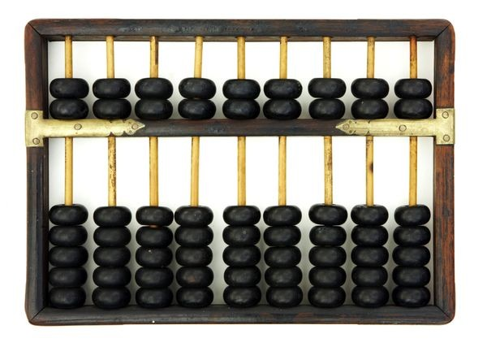
* **Napier’s Bones**: Invented by John Napier to simplify multiplication and division using rods.

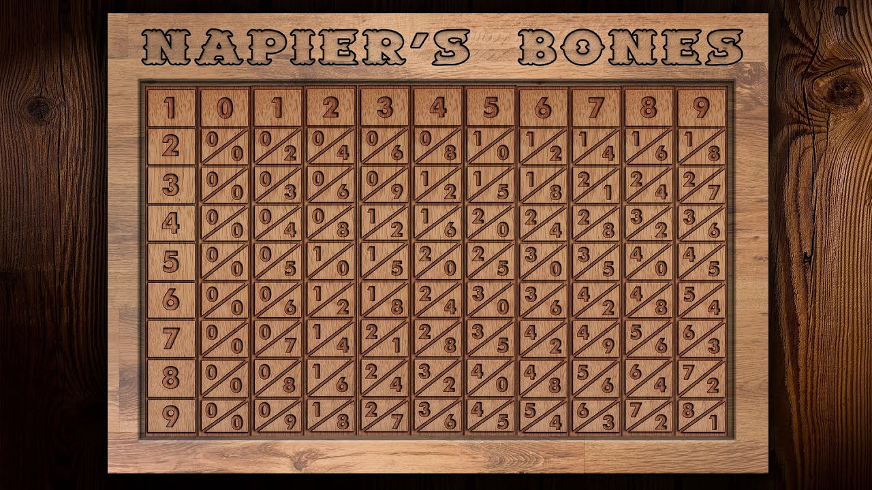

* **Pascaline**: Developed by Blaise Pascal; a mechanical calculator that could add and subtract.

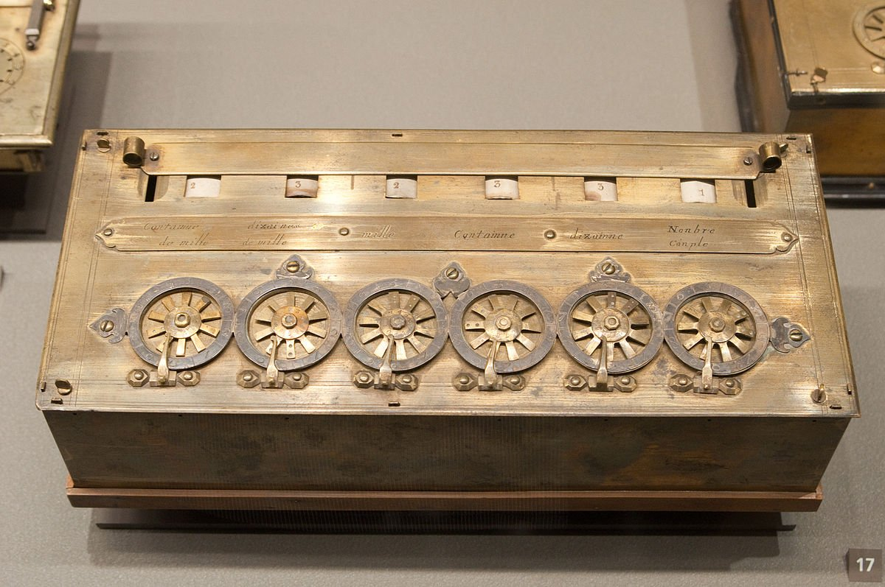

* **Leibniz Calculator**: Improved on Pascaline and could perform multiplication and division.

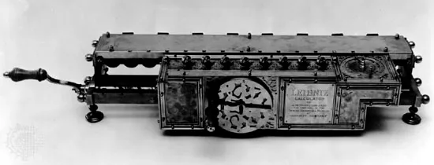

* **Analytical Engine**: Designed by Charles Babbage; considered the foundation of modern computers. It introduced concepts like input, output, memory, and processing.

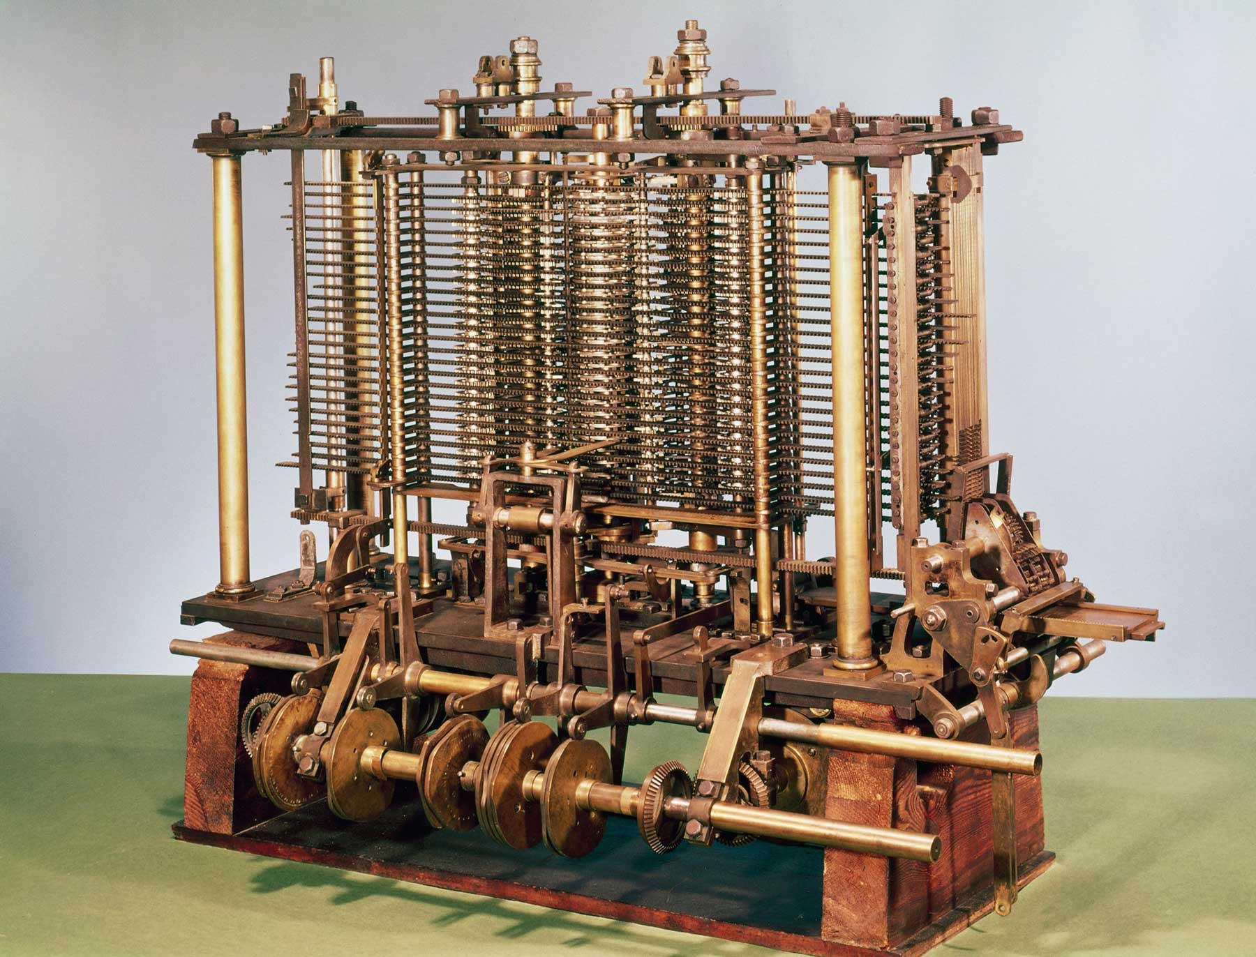

* **Tabulating machine (Right)**: An American Statistician - Herman Hollerith invented this machine in the year 1890. Tabulating Machine was a punch card-based mechanical calculator. It could compute statistics and record data or information.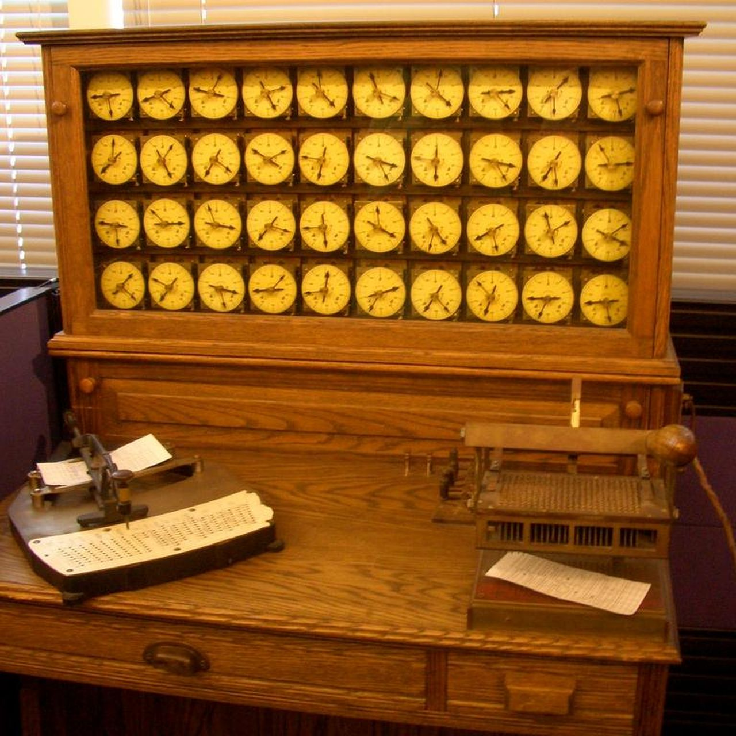

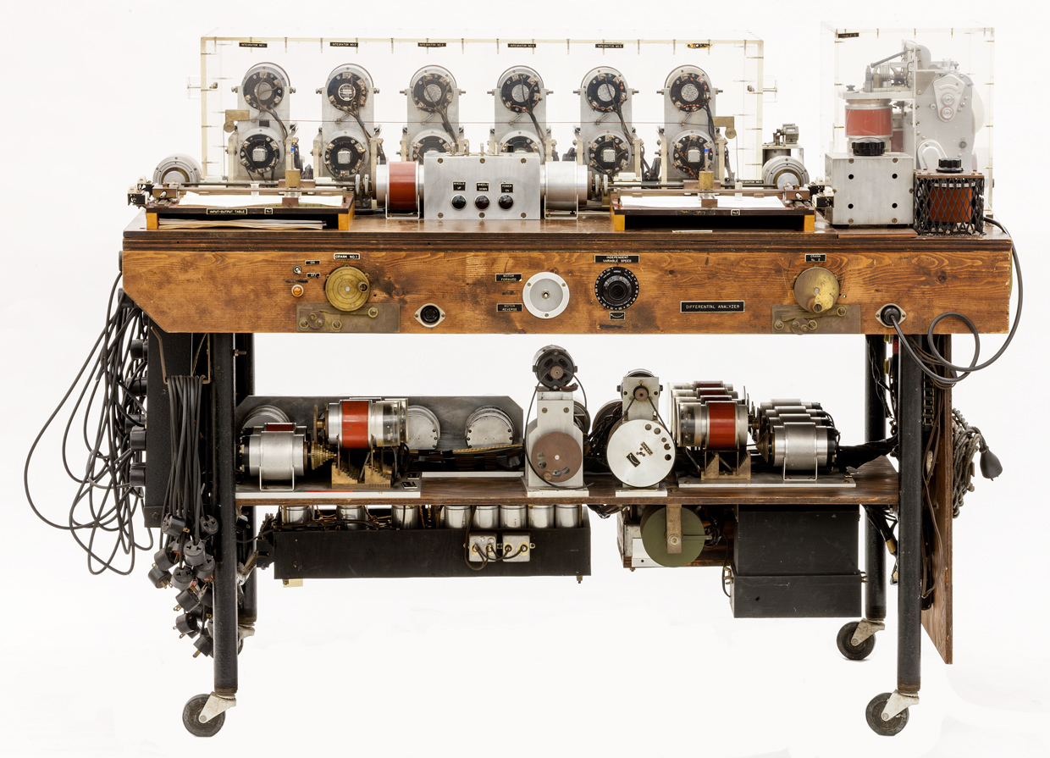

* **Differential Analyzer (Left) :** Vannevar Bush introduced the first electrical computer, the Differential Analyzer, in 1930. It was capable of performing 25 calculations per minute.
* **Mark I:** The next successful computing machine invented was a digital computer known as Mark-I. It was invented by Howard Aiken in 1944. Mark-I could add three numbers having eight digits in one second.

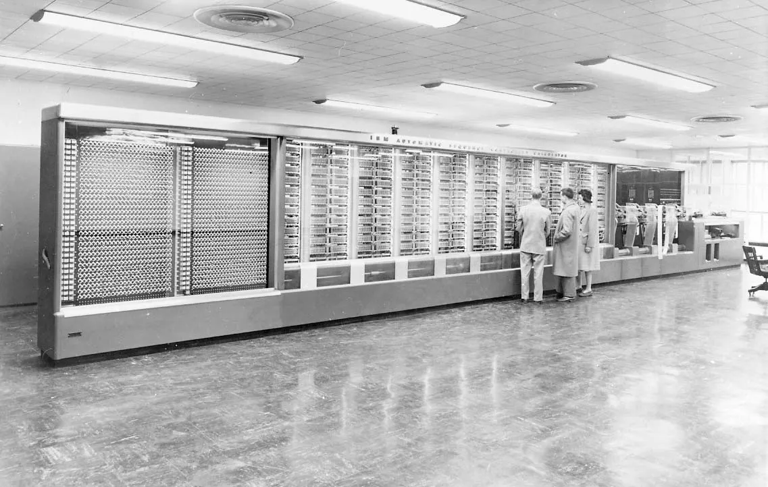

### **1.1.2 Computer Generations**

Computers are categorized into generations based on the technology used:

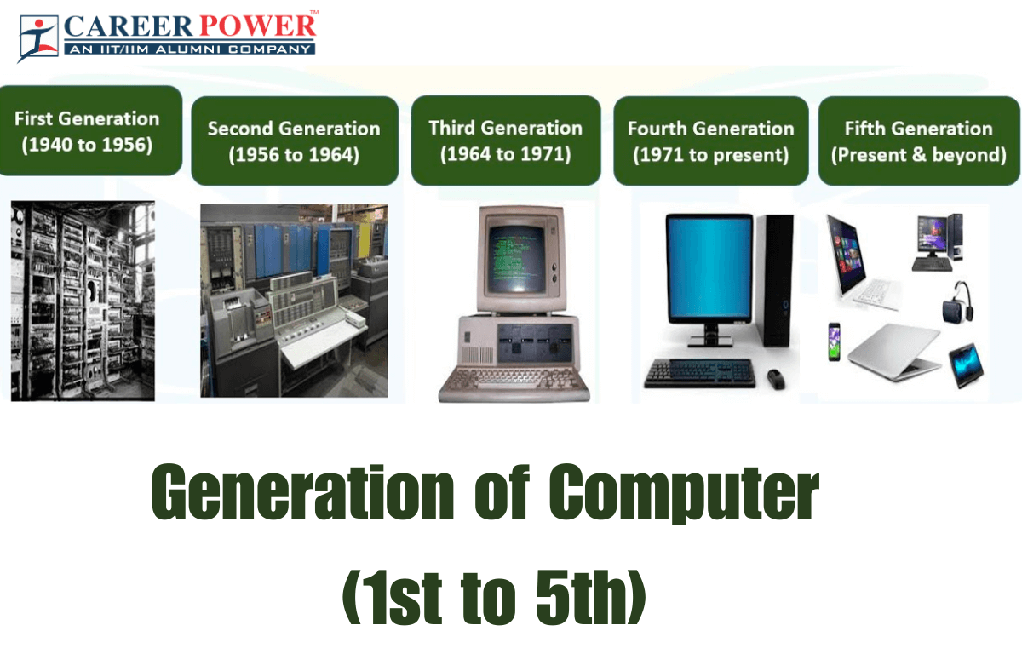

* **First Generation (1940–1956)**: Used vacuum tubes; very large, consumed much power, and produced a lot of heat.
* **Second Generation (1956–1963)**: Used transistors; smaller, faster, and more reliable than the first generation.
* **Third Generation (1964–1971)**: Used integrated circuits (ICs); increased efficiency and reduced size.
* **Fourth Generation (1971–Present)**: Used microprocessors; led to personal computers (PCs).
* **Fifth Generation (Present and Future)**: Based on artificial intelligence, machine learning, and quantum computing concepts.

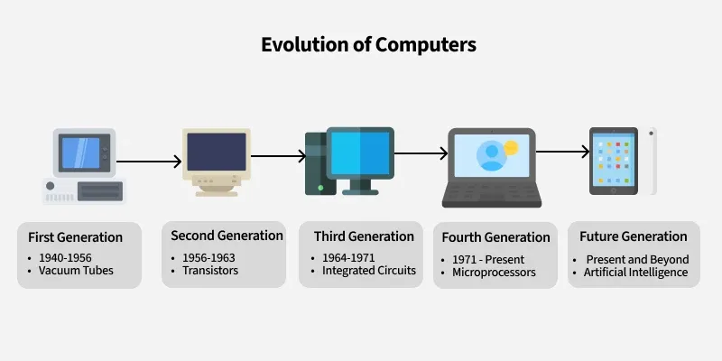

## **1.2 Understanding Systems and Their Types**

A **system** is a group of related components that work together to achieve a common goal.

### **1.2.1 Natural and Artificial Systems**

* **Natural Systems**: Systems found in nature, such as the solar system, human body, and ecosystem.

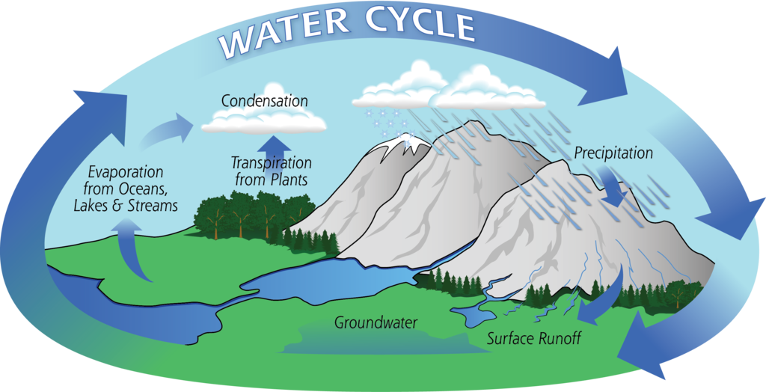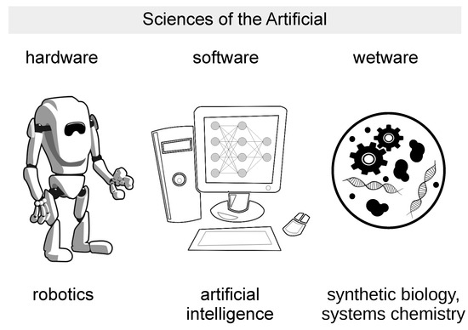

* **Artificial Systems**: Man-made systems designed to perform specific tasks, such as computers, transportation systems, and communication networks.

## **1.3 Core Components of a Computer System**

A computer system consists of hardware and software components working together.

### **1.3.1 Input Devices**

Input devices are used to enter data and instructions into the computer:

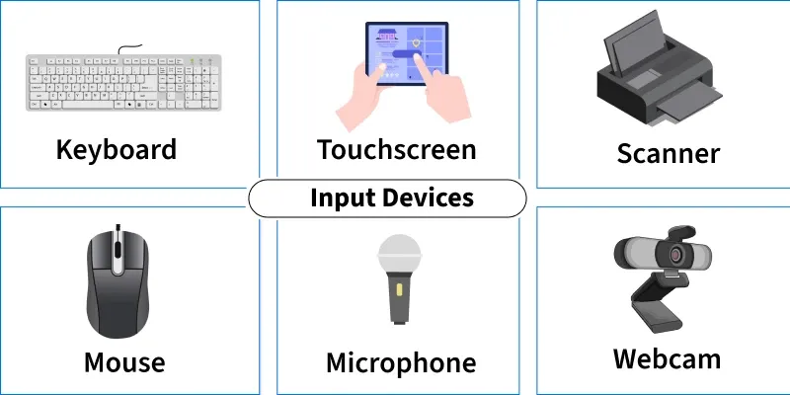

* Keyboard
* Mouse
* Scanner
* Microphone
* Webcam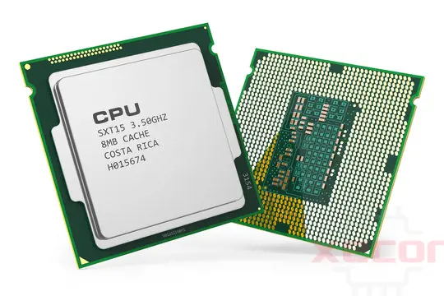

### **1.3.2 System Unit**

The system unit contains the main electronic components:

* **CPU (Central Processing Unit)/Microprocessor**: Performs processing and decision-making.
  + **ALU (Arithmetic Logic Unit)**: Performs arithmetic and logical operations.
  + **Control Unit (CU)**: Controls and coordinates all activities.
* **Motherboard**: Main circuit board connecting all components.

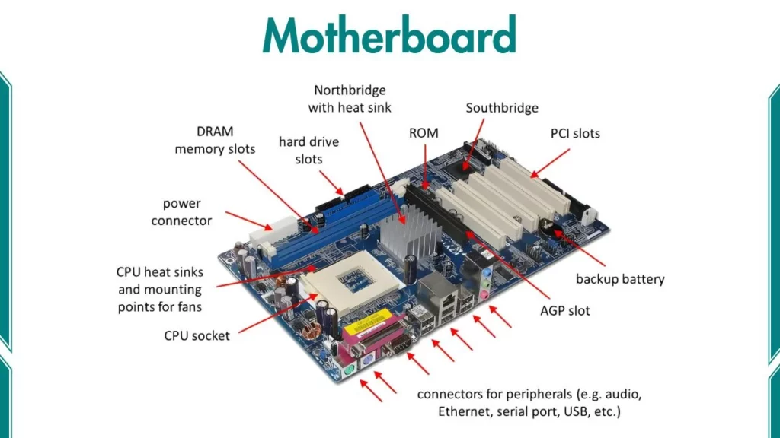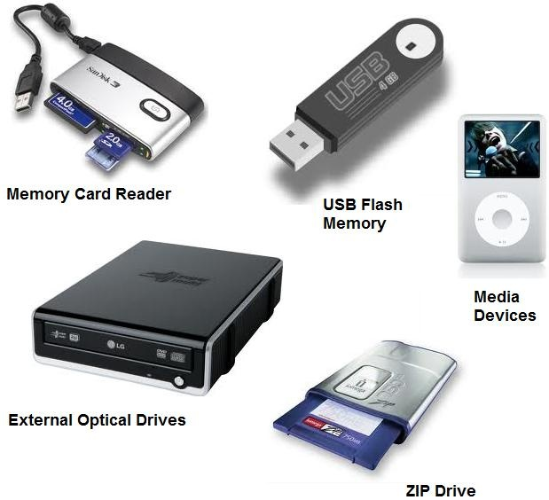

### **1.3.3 Storage Devices**

Used to store data and programs:

* **Primary Storage**: RAM, ROM
* **Secondary Storage**: Hard disk, SSD, USB flash drive, memory card

### **1.3.4 Output Devices**

Output devices display processed results:

* Monitor
* Printer
  + **Impact Printers:** Impact printers use an electro-mechanical mechanism which causes the character shape to strike against the paper and leave an image of the character on the paper. Dot matrix printer is the most commonly used impact printer.
  + **Non-Impact Printers:** Non-Impact printer prints without striking the paper. There are two types of nonImpact printers which are inkjet and laser printers. Inkjet printers store ink in cartridges and spray on paper through fine nozzles on the print-head. Laser printers use technology similar to photocopying machines.
* Speakers
* Projector
* Plotter:
  + An output device used for printing engineering drawings, machine parts, building designs, maps, charts and panna-flexes etc. on large size papers/sheets. Such large size printing is not possible on printers.

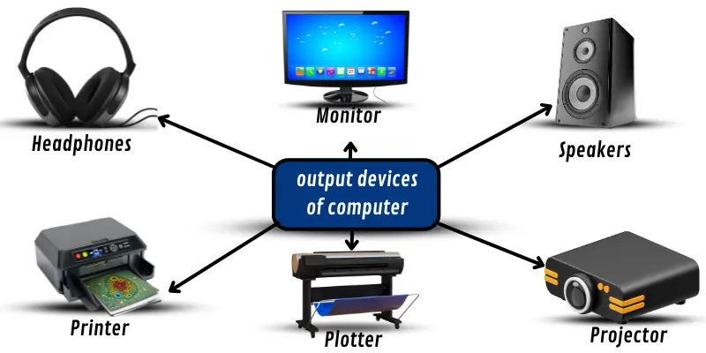

### **1.3.5 Ports, Expansion Slots and Expansion Cards**

* **Ports**: Used to connect external devices (USB, HDMI, VGA).
* **Expansion Slots**: Slots on motherboard to add extra features.
* **Expansion Cards**: Graphics card, sound card, network card.

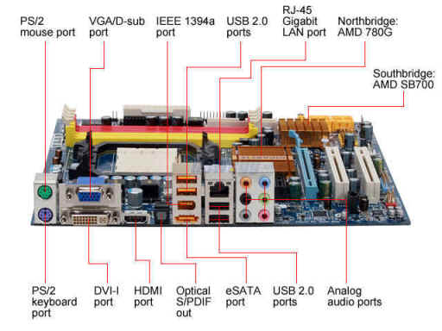

## **1.4 Von Neumann Architecture**

Von Neumann Architecture describes the structure of a computer system where: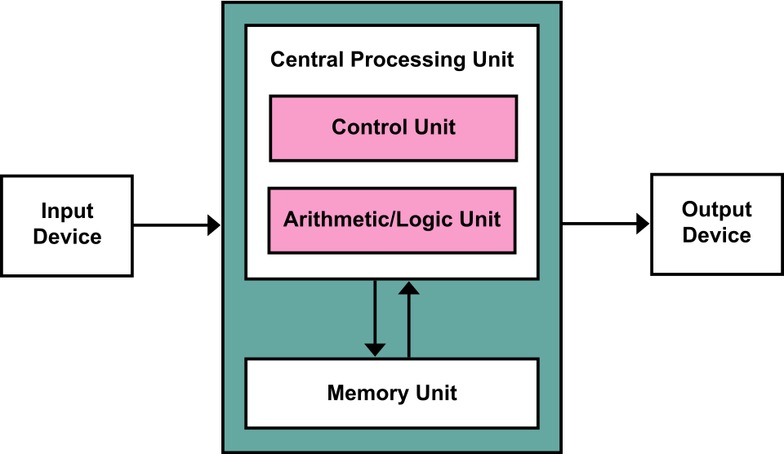

* Data and instructions are stored in the same memory.
* CPU fetches instructions one by one.  
  Main components include Input Unit, Output Unit, Memory Unit, and CPU.

**Key Components:**

* **Central Processing Unit (CPU):** Executes instructions, contains the ALU, Control Unit, and registers.
* **Arithmetic Logic Unit (ALU):** Performs arithmetic and logic operations.
* **Control Unit (CU):** Manages instruction fetching and data flow.

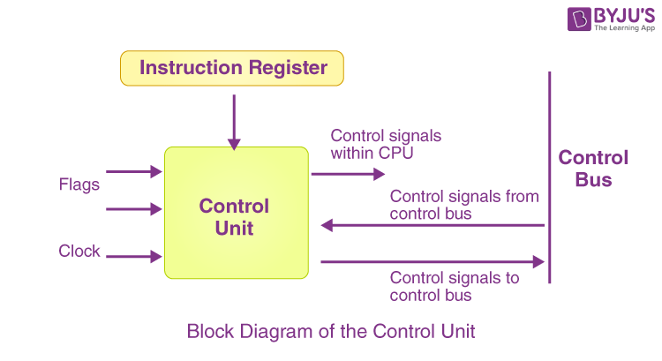

* **Memory Unit:** Stores both program instructions and data.
* **Registers:** High-speed storage within the CPU (e.g., Program Counter, Memory Address Register, Accumulator).
* **Input/Output (I/O) Devices:** For interaction with the outside world.
* **Buses:** The pathways or lines by which data is transmitted from one part of a computer to another.

## **1.5 Data Transmission within a Computer System**

Data transmission refers to the flow of data between components:

* Data travels through **buses** (data bus, address bus, control bus).
* Signals can be electrical or digital.

## 

* **Data Paths:** Inside the CPU, data paths are dedicated paths known as data circuits that facilitate the movement of data between various functional units. These functional units include the Arithmetic Logic Unit (ALU), registers, cache, and other components involved in data processing.
* **Registers:** Registers are small, high-speed storage units that hold data that is frequently used by the CPU during processing.
* **Memory Hierarchy:** Modern computers use a memory hierarchy to improve data transmission.
* **Instruction Cycle:** When a program is executed, it goes through a series of steps called the instruction cycle. It is called the fetch-decode-execute cycle.
* Pipeline Processing: Many modern CPUs use pipelining to increase efficiency. In a pipeline, multiple instructions are in different stages of execution simultaneously.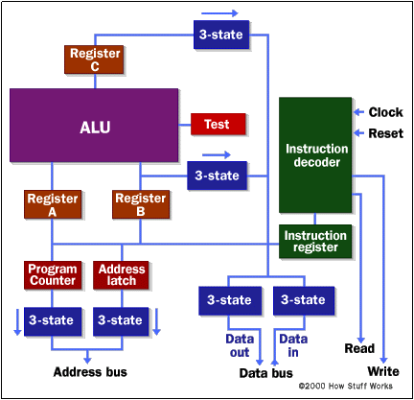
* **Interrupts and I/O:** Input/output devices (e.g., keyboard, mouse, display, network interface) communicate with the CPU using interrupts. An interrupt is a signal that halts the current program's execution to handle an important event.
* **Parallelism:** Some computer architectures use parallelism to improve data transmission speed.

## 

## **1.6 Types and Hierarchy of Computer Memory**

Computer memory is organized in a hierarchy based on speed, cost, and capacity.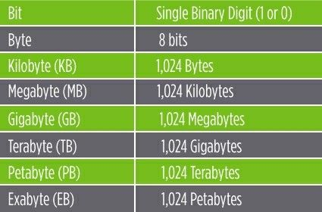

### **1.6.1 Memory Terminology**

* **Bit**: Smallest unit of data (0 or 1)
* **Byte**: 8 bits
* **KB, MB, GB, TB**: Units of memory measurement
  + **Memory Word:** In computing, the smallest amount or size of data that a computer can process is called memory word.
  + **Word Size:** Word size refers to the number of bits that a computer's CPU can process or manipulate in a single instruction or operation.

### **1.6.2 Memory Built-up and Retention Power**

* **Built-up**: Physical structure of memory
* **Retention Power**: Ability to retain data without power
* **Chip Memory:** Chip is a small piece of semi-conducting material (usually silicon). A small circuit called IC (Integrated Circuit) is embedded on it. A typical chip contains millions of electronic components (transistors).
* **Magnetic Memory:** One of the most widely used types of digital data storage is magnetic memory/storage. This refers to any type of data storage using a magnetized medium. Magnetic tapes and disks are examples of magnetic memory devices. A thin layer of magnetic material is coated on the surface of magnetic tape and magnetic disks.
* **Optical Memory:** In optical-storage technology, a laser beam encodes digital data onto an optical disk in the form of tiny pits and lands arranged in concentric tracks on the disk's surface as shown in Fig. 1.40. A low-power laser scanner is used to "read" data or information from these pits and lands, and convert it to digital form.

To summarize,

* Chip memory excels in performance and is used for active, high-speed computing tasks.
* Magnetic memory provides high capacity storage at a lower cost, ideal for large volumes of less frequently accessed data.
* Optical memory is a niche solution for durable, physical media distribution and archiving.

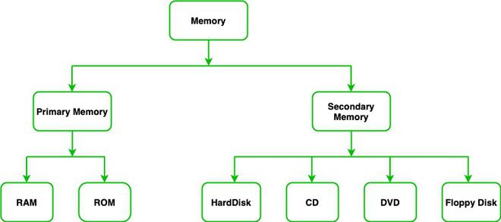

### **1.6.3 Main Memory**

* **RAM (Random Access Memory)**: Temporary and volatile
  + It stores the Basic Input/Output System (BIOS) of a computer that controls input/output devices and the startup or boot process.
* **ROM (Read Only Memory)**: Permanent and non-volatile
  + RAM is high speed memory installed on the motherboard.
  + It is a READ/WRITE memory.
  + Information can be read from or written into it
* **Cache Memory:** Cache is a very small amount of extremely fast memory inside the microprocessor or on the motherboard. It is faster and more expensive than RAM.

### **1.6.4 Volatile and Non-Volatile Memory**

* **Volatile Memory**: Loses data when power is off (RAM)
  + It is a temporary memory, that requires power (electricity) to maintain the stored information
* **Non-Volatile Memory**: Retains data without power (ROM, hard disk)
  + It is a permanent memory that can retain the stored information even when powered off.

## **1.7 Software Engineering and Hardware Engineering**

* **Hardware Engineering**: Design and development of physical components.
  + **Digital Hardware Engineering:** It deals with designing and developing digital circuits and components such as processors, memory units, etc.
  + **Integrated Circuit (IC) Design:** It focuses on designing integrated circuits, including CPUs (Central Processing Units), GPUs (Graphics Processing Units), etc.
  + **Computer Architecture:** It deals with designing the structure and organization of computer systems, including CPU architecture and memory hierarchy, etc.
  + **Embedded Systems Design:** It focuses on designing hardware systems that are integrated into larger systems or devices, such as microcontrollers, sensors, etc.
* **Software Engineering**: Development, testing, and maintenance of software.
  + **Application Software Engineering:** This focuses on developing software applications that fulfill specific user requirements, such as web applications, mobile apps, desktop software, etc.
  + **System Software Engineering:** This involves designing and developing software that provides a platform for other software to run on, such as operating systems, etc.
  + **Embedded Software Engineering:** This refers to the specialized field of software engineering that focuses on developing and testing software that is embedded within hardware devices or systems. For example Automotive Embedded Systems, etc.
  + **Enterprise Software Engineering:** This involves developing software solutions for large-scale enterprises to automate processes, manage data, and facilitate communication within the organization.
  + **Game Development:** This area involves creating video games, including game engines, graphics, audio, and animation.

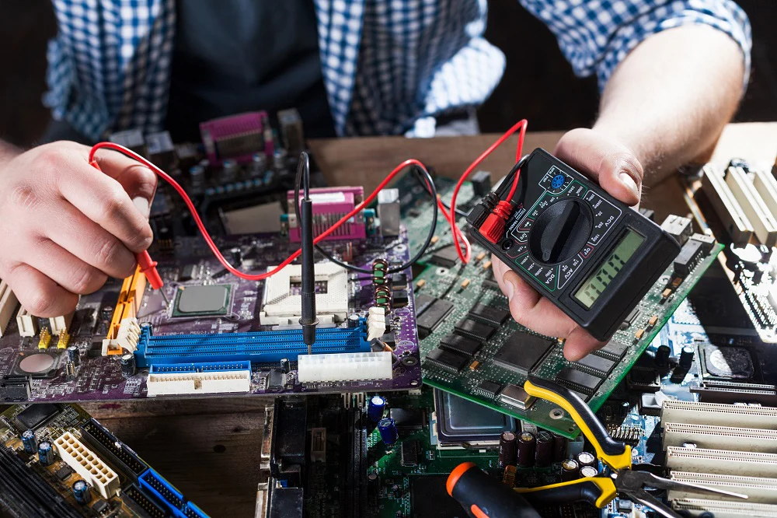

## **1.8 Computer Software**

Software is a set of instructions that tells the computer what to do.

### **1.8.1 System Software**

System software serves as an intermediary between the user and the hardware, making it easier for users to interact with and utilize computer systems effectively.

* **Operating Systems (Windows, Linux)**
  + The OS facilitates user interaction by providing a user-friendly interface.
  + It manages input/output operations.
  + It looks after the allocation of tasks to the processor.
* **Device Drivers**
  + Device drivers are software components that facilitate communication between the operating system and hardware devices like printers, graphics cards, and network adapters.
* **Utility Programs:** System utilities are tools that help manage and maintain the computer system.
* **Compiler and Assembler:** These tools are essential for converting high-level programming languages (like C++, Java, or Python) into machine code that the computer's processor can understand.
* **Linkers and Loaders:** Linkers and loaders are programs that help with the execution of programs. Linkers combine multiple object files (compiled code) into a single executable file, while loaders load these files into memory for execution.
* **Firmware:** Firmware is a type of software that is permanently stored on hardware devices. It provides low-level control over the device's operation.

### **1.8.2 Application Software**

* General-purpose software (Word, Excel)
* Specific-purpose software (School management systems)

Some examples of application software are:

* Productivity Software
* Business Software
* Entertainment Software
* Educational Software

### **1.8.3 Programming Languages**

A programming language is a structured and systematic method of communicating instructions to a computer. It consists of a set of predefined commands, syntax, and rules that allow programmers to write instructions, enabling the computer to perform specific tasks or solve problems.

* **Low-Level Languages**: Machine language, Assembly language
* **High-Level Languages**: C, C++, Java, Python
* **Machine Language:** Programming language that is directly understood by computer hardware is known as machine language. Machine language is associated with computer architecture. Therefore, programs written in machine language for one computer will not work on another because of design differences.
* **Assembly Language:** Assembly language consists of symbolic codes or abbreviations known as mnemonics. It was developed to make computer programming easier than machine language. The abbreviations used in assembly language make it easier to learn and write programs compared to machine language.

High-level languages (like Python, Java) are human-friendly, portable, and abstract from hardware, focusing on logic with easy syntax, while low-level languages (like Assembly, Machine Code) are hardware-specific, offer direct control, run faster, but are harder to read and use, requiring deeper hardware knowledge for performance-critical tasks.

**High-Level Languages**

* Abstraction: High (closer to human language, far from machine).
* Ease of Use: Easy to read, write, and debug (e.g., Python, Java).
* Portability: Highly portable; runs on different machines with a compiler/interpreter.
* Performance: Generally slower due to translation overhead.
* Memory: Often uses automatic memory management.

**Low-Level Languages**

* Abstraction: Low (closer to machine code, less hidden detail).
* Ease of Use: Difficult to read/write; machine-dependent (e.g., Assembly, Machine Code).
* Portability: Not portable; tied to specific hardware.
* Performance: Very fast and efficient (direct hardware control).
* Memory: Requires manual memory management and offers full control.

**Procedural and Structured Languages**

Procedural programming is based upon the concept of modular programming. Modular programs consist of one or more modules. A module is a group of statements that can be executed more than once in a program. Each module in the program performs a specific task. It is easy to design, modify and debug a program in a procedural language since it provides better programming facilities.

Structured languages consist of three fundamental elements, which are sequence, selection and repetition

* **Sequence:** It means, writing program statements in a logical sequence. Each step in the sequence must logically progress to the next without producing any undesirable effects.
* **Selection:** It allows the selection of any number of statements based on the result of evaluation of a condition which may be true or false. Examples of statements that implement selection in programming are if, else-if, switch, etc.
* **Repetition (loops):** It means executing one or more statementsa number of times until a condition is satisfied. Repetition is implemented in programs using statements, such as for and while loops.

**Object-Oriented Programming Languages**

Object-Oriented Programming (OOP) languages use objects, classes, inheritance, and polymorphism to structure code, with popular examples including Java, Python, C++, C#, Ruby, and JavaScript

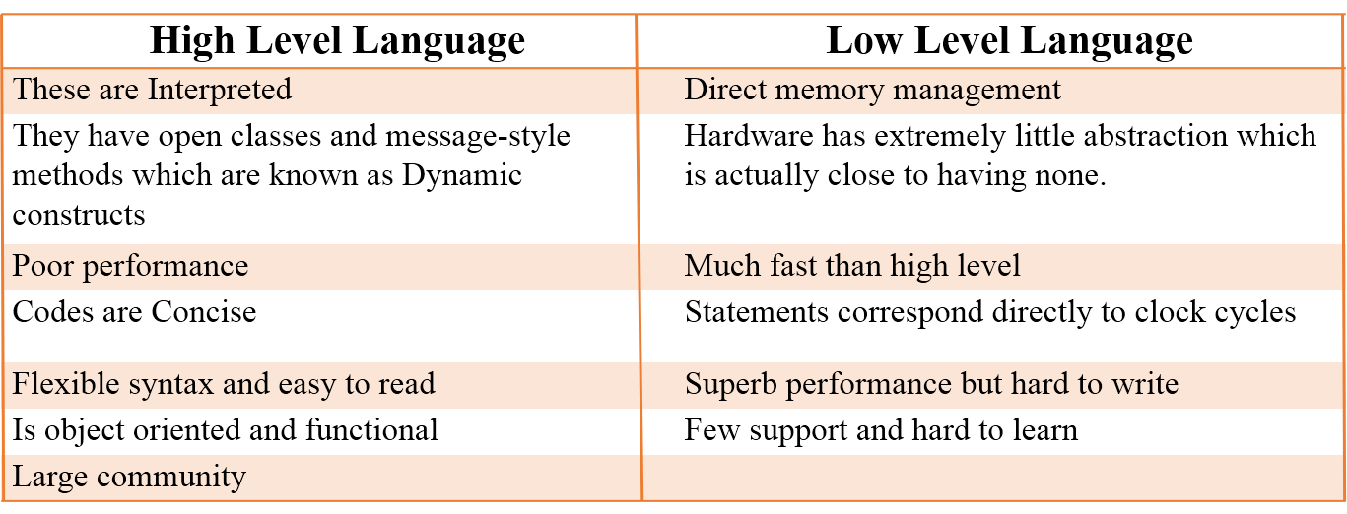

## **1.9 Data Communication**

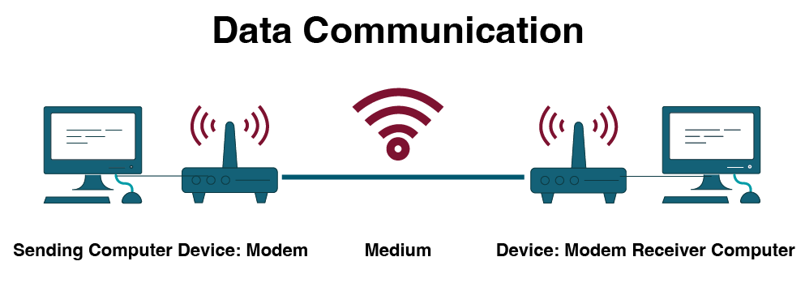

Data communication is the process of **transferring data and information from one device to another through a transmission medium**. It plays a vital role in modern computer systems by enabling sharing of data, resources, and services.

### **Key Characteristics of Effective Data Communication**

For data communication to be effective, it must have:

* **Delivery**: Data must reach the correct destination.
* **Accuracy**: Data must be delivered without errors.
* **Timeliness**: Data must reach on time, especially for real-time applications.
* **Security**: Data should be protected from unauthorized access.

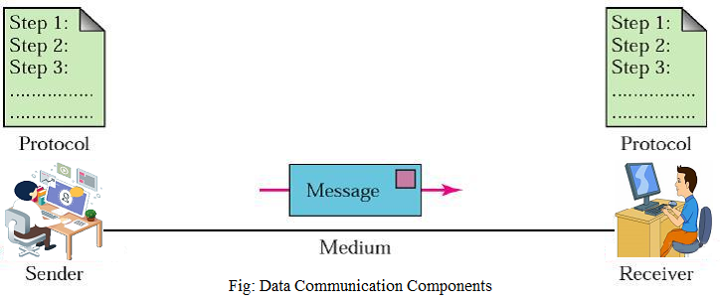

### **1.9.1 Network Communication Components**

The basic components required for data communication are:

* **Sender**: The device that sends data (computer, mobile phone).
* **Receiver**: The device that receives data.
* **Message**: The data or information to be transmitted.
* **Transmission Medium**: The physical or wireless path through which data travels (cables, radio waves).
* **Protocol**: A set of rules that governs data communication (e.g., TCP/IP).

### **1.9.2 Modes of Network Communication**

Modes describe the direction of data flow:

* **Simplex Mode**: One-way communication only (e.g., keyboard to computer).
* **Half-Duplex Mode**: Communication in both directions, but not at the same time (e.g., walkie-talkie).

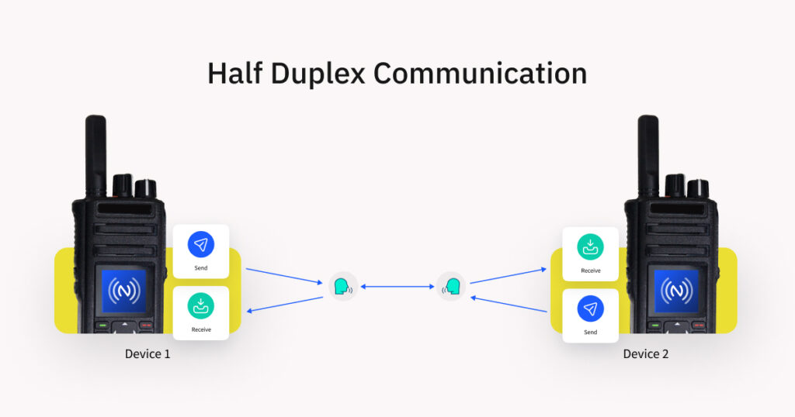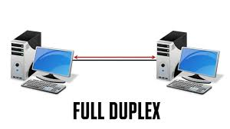

* **Full-Duplex Mode**: Communication in both directions at the same time (e.g., telephone call).

**Synchronous and Asynchronous Communication:**

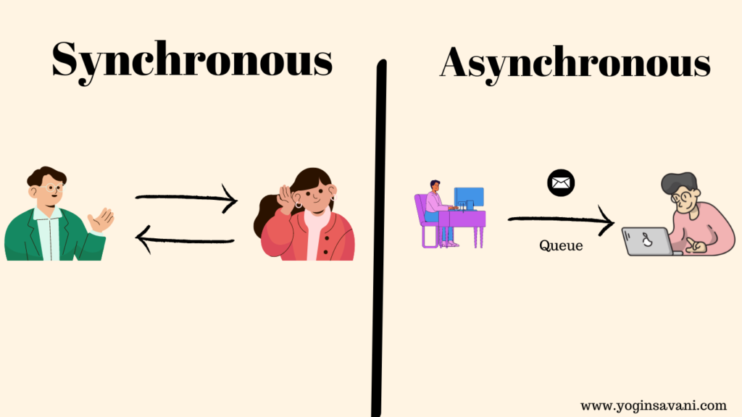

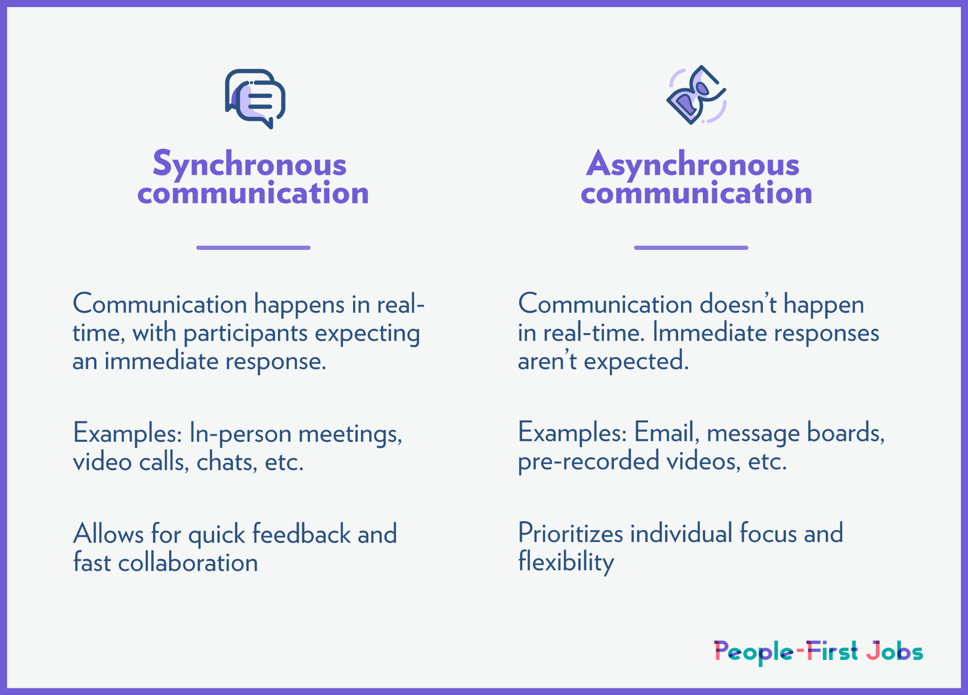

### **1.9.3 Communication Devices**

Devices that help in data transmission:

* **Modem (Modulator-Demodulator)**: Converts digital signals into analog and vice versa.
* **Router**: Connects multiple networks and directs data packets.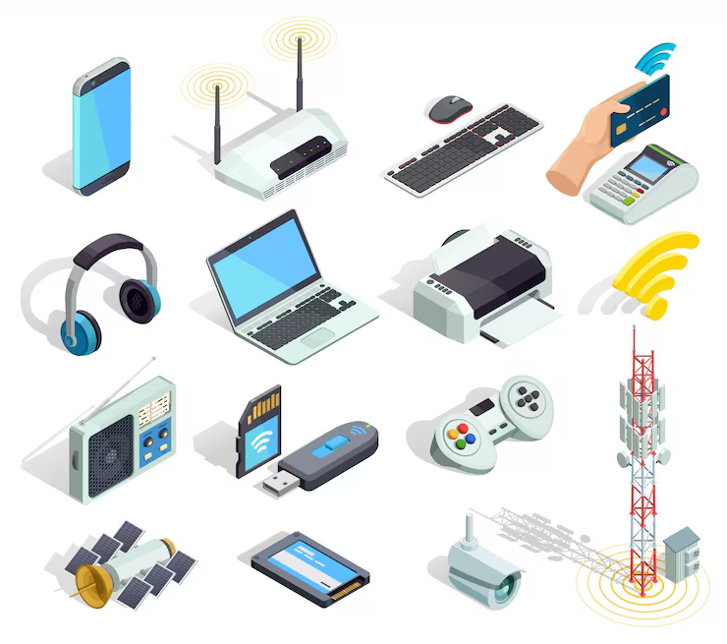
* **Switch**: Connects devices within a network and forwards data efficiently.
* **Hub**: Basic networking device that broadcasts data to all connected devices.
* **Access Point**: Provides wireless connectivity to devices.

### **1.9.4 Network Architecture**

Network architecture defines how computers are organized:

* **Client-Server Architecture**: A central server provides resources to clients. It is secure and commonly used in schools and offices.

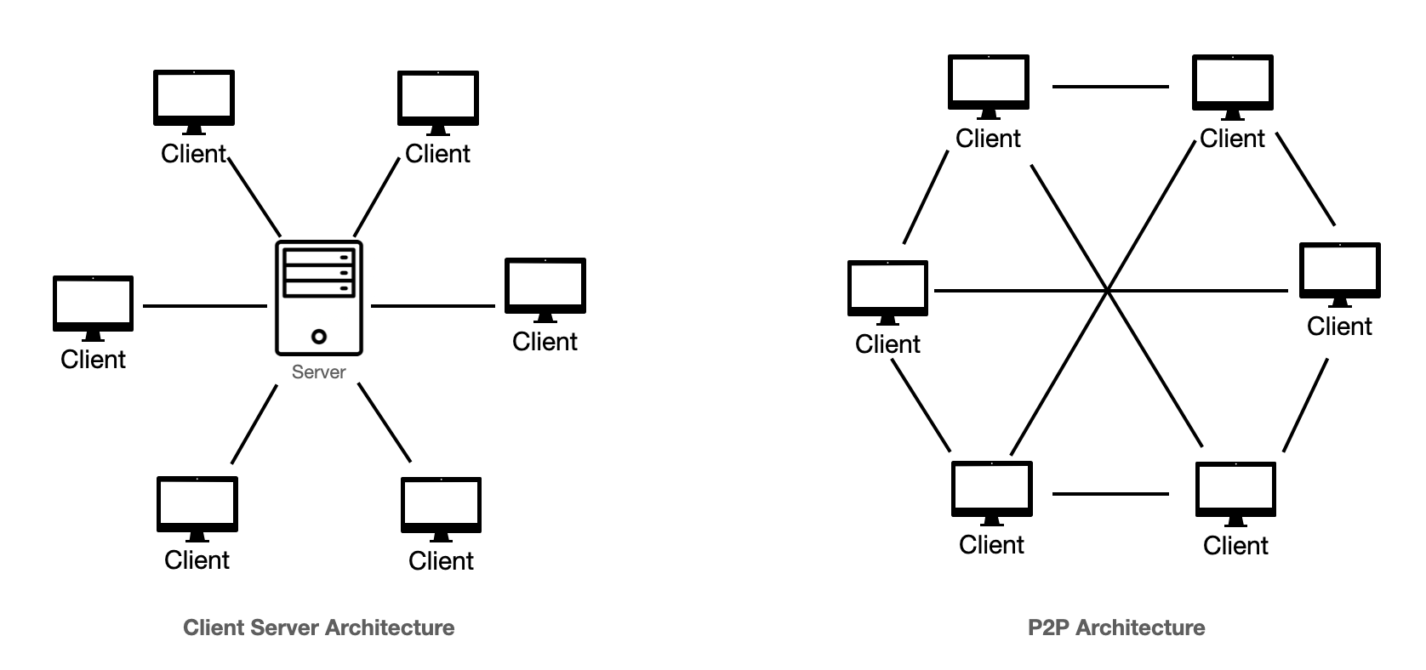

* **Peer-to-Peer (P2P) Architecture**: All computers have equal status and can share resources directly.

### **1.9.5 Types of Networks**

Networks are classified based on geographical coverage:

* **LAN (Local Area Network)**: Covers a small area such as a school or office.
  + Spans a small physical area.
  + DSL Modem Switch Network Printer Uses high-speed wired/wireless connections between computers.
  + It is a very reliable network.
  + Communication errors are very rare. It consists of a limited number of computers.
* **MAN (Metropolitan Area Network)**: Covers a city or town.
  + It is larger than a LAN and smaller than a WAN.
  + Covers an area of between 5 to 50 km diameter.
  + Uses fiber optic cable or microwave transmission.
  + Provides high-speed communication.
  + Used by telephone companies, Internet Service Providers and cable TV companies.
* **WAN (Wide Area Network)**: Covers large areas such as countries or continents.
  + Spans a large physical area.
  + It can be worldwide like the Internet.
  + Communication speed is slow compared to LAN.

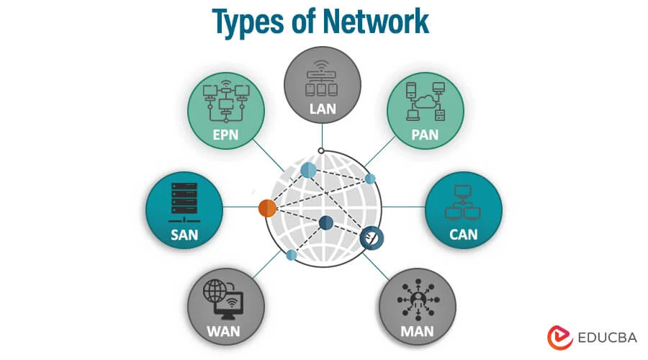

### **1.9.6 Wireless Networks**

Wireless networks transmit data using **radio waves or infrared signals** instead of cables.  
Examples include:

* **Wi-Fi**: Used for internet access in homes and institutions.
* **Bluetooth**: Used for short-range communication.
* **Cellular Networks (3G, 4G, 5G)**: Used for mobile communication.

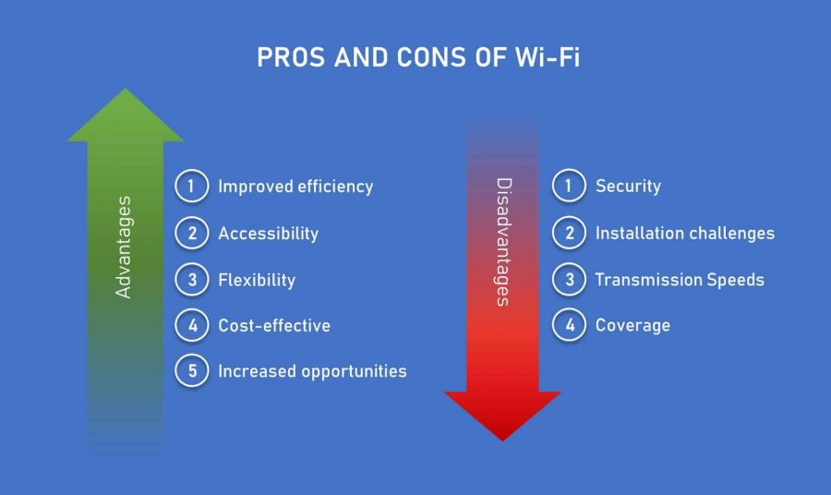

### **1.9.7 Network Topologies**

Topology refers to the **physical or logical layout of a network**:

* **Bus Topology**: All devices share a single communication line.
* **Star Topology**: All devices are connected to a central hub or switch.
* **Ring Topology**: Devices are connected in a circular manner.
* **Mesh Topology**: Each device is connected to every other device.

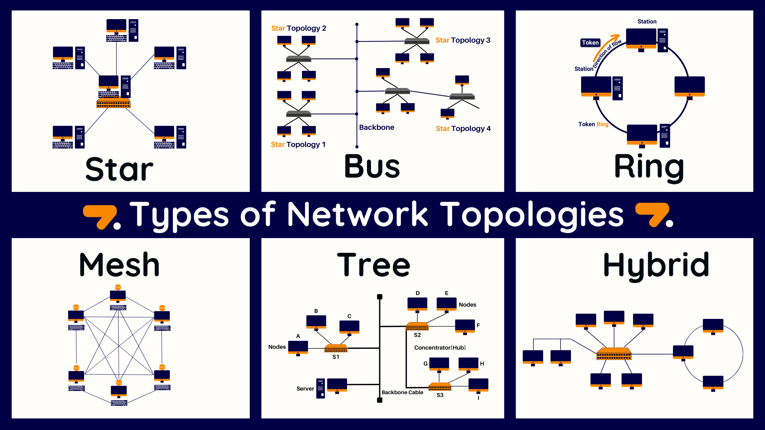

### **1.9.8 Packet Switching and Circuit Switching**

* **Packet Switching**: Data is divided into small packets and sent independently. Used in the Internet.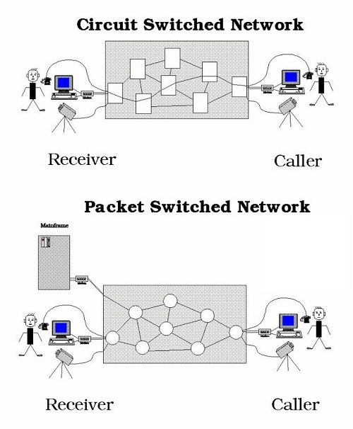
* **Circuit Switching**: A dedicated communication path is established before transmission. Used in traditional telephone systems.

**Circuit Switching**

* **Connection:** Establishes a dedicated, fixed path (circuit) before data transfer.
* **Resource Use:** Reserves all resources (bandwidth) for the session, even when idle, leading to inefficiency.
* **Data Flow:** Data travels as a continuous stream in sequence.
* **Delay:** Uniform and low, ideal for real-time.
* **Examples:** Traditional telephone networks (PSTN).

**Packet Switching**

* **Connection:** No dedicated path; uses dynamic routing.
* **Resource Use:** Shares bandwidth efficiently; resources are used only when needed.
* **Data Flow:** Data broken into packets, sent independently, and reassembled at the destination (may arrive out of order).
* **Delay:** Variable (jitter) due to congestion and different routes, but can handle bursts well.
* **Examples:** The Internet (TCP/IP), email, web browsing, VoIP.

### **1.9.9 Data Communication Standards**

Standards are **international rules and guidelines** that ensure compatibility between devices from different manufacturers.  
Examples include: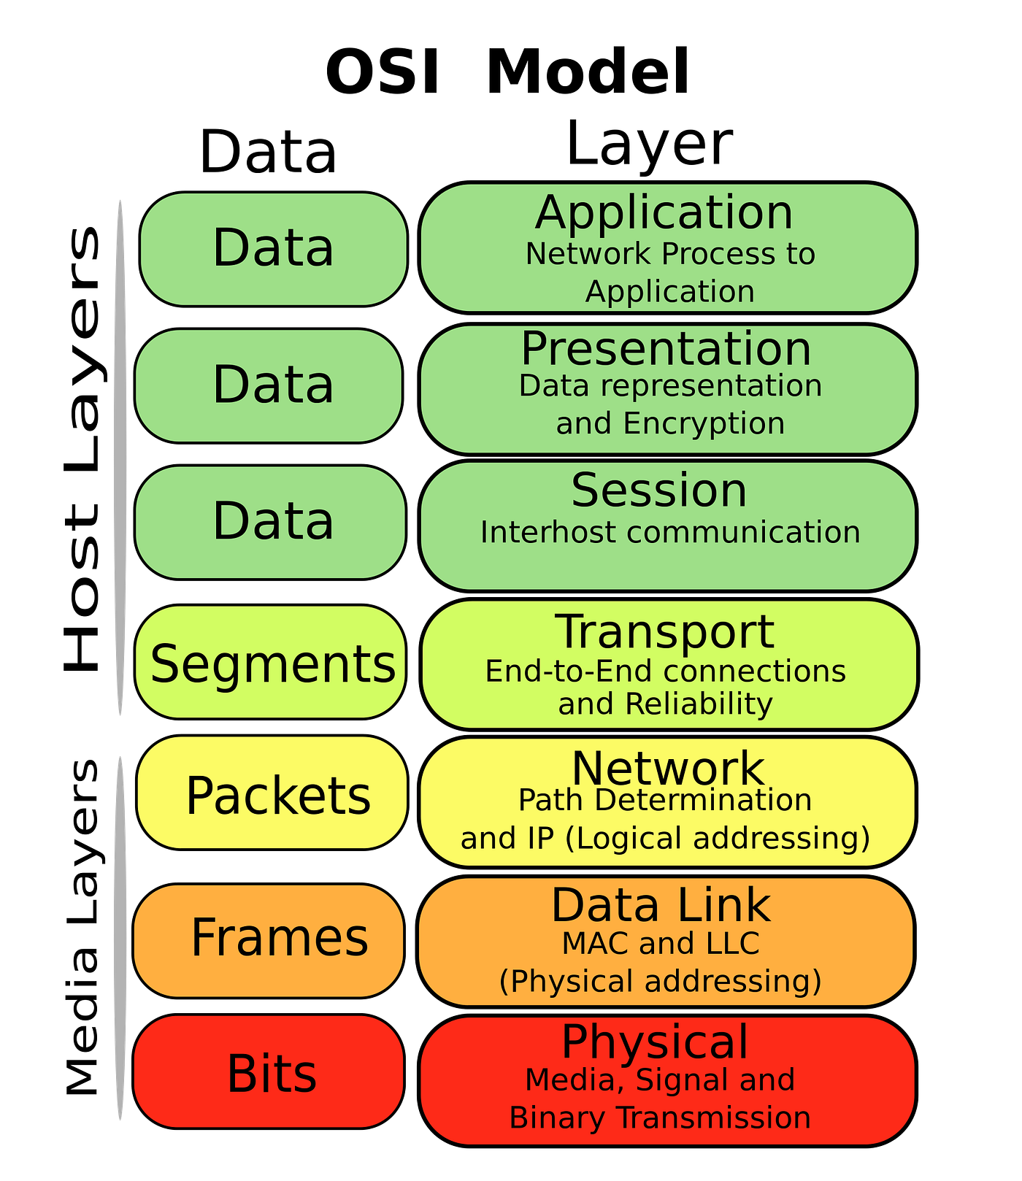

* IEEE standards
* Ethernet standards
* Wi-Fi standards

### **1.9.10 OSI Model**

The **OSI (Open Systems Interconnection) Model** is a seven-layer framework that explains how data is transmitted over a network:

1. **Physical Layer** – Transmits raw bits through the medium.
2. **Data Link Layer** – Ensures error-free data transfer between nodes.
3. **Network Layer** – Handles routing and logical addressing.
4. **Transport Layer** – Ensures complete data transfer.
5. **Session Layer** – Manages communication sessions.
6. **Presentation Layer** – Translates, encrypts, and compresses data.
7. **Application Layer** – Provides services to users (email, web).

### **1.9.11 Data Communication Protocols**

Protocols are **rules that control data transmission**.  
Common protocols include:

* **TCP/IP**: Core protocol of the Internet.
* **HTTP**: Used for web communication.
* **FTP**: Used for file transfer.
* **SMTP**: Used for sending emails.

### **1.9.12 The Internet**

The Internet is a **global network of interconnected computers** that enables communication and information sharing.

Major Internet services include:

* Email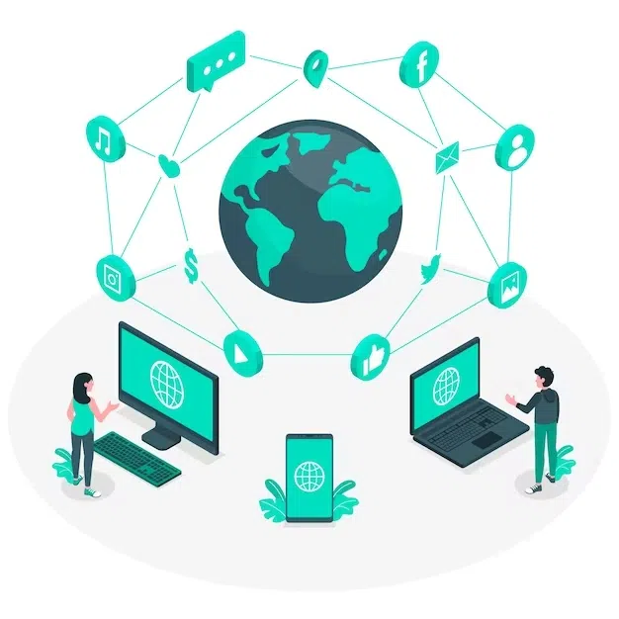
* World Wide Web (WWW)
* File sharing
* Online communication and cloud services



